

Repository Implementation

Documentation

Leads Team | Leads Project | 5 Dec 2018

# Repository Architecture:

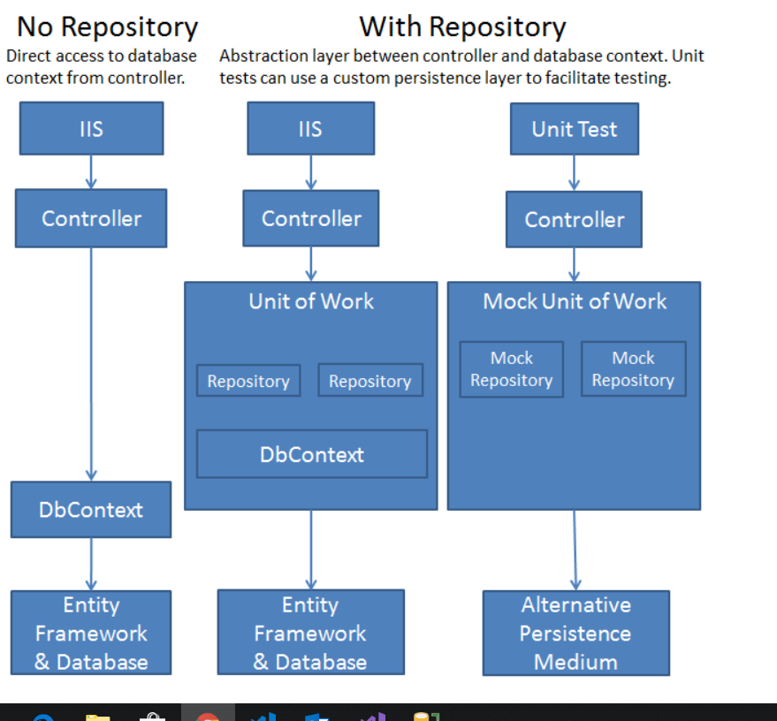

# Creating Student Repository Example:

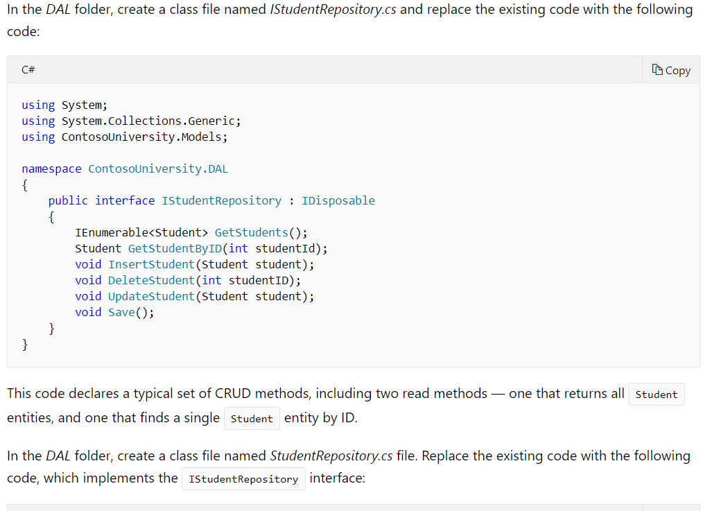

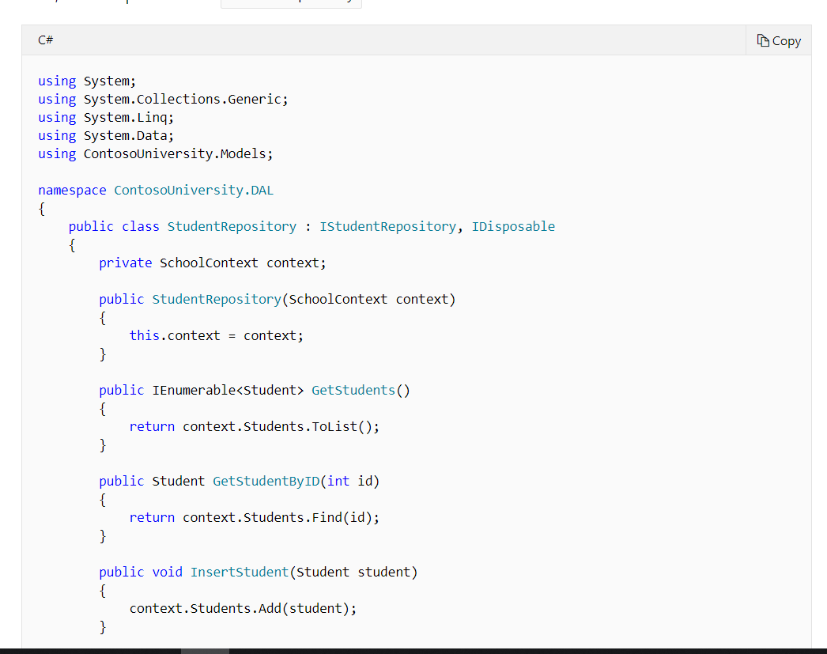

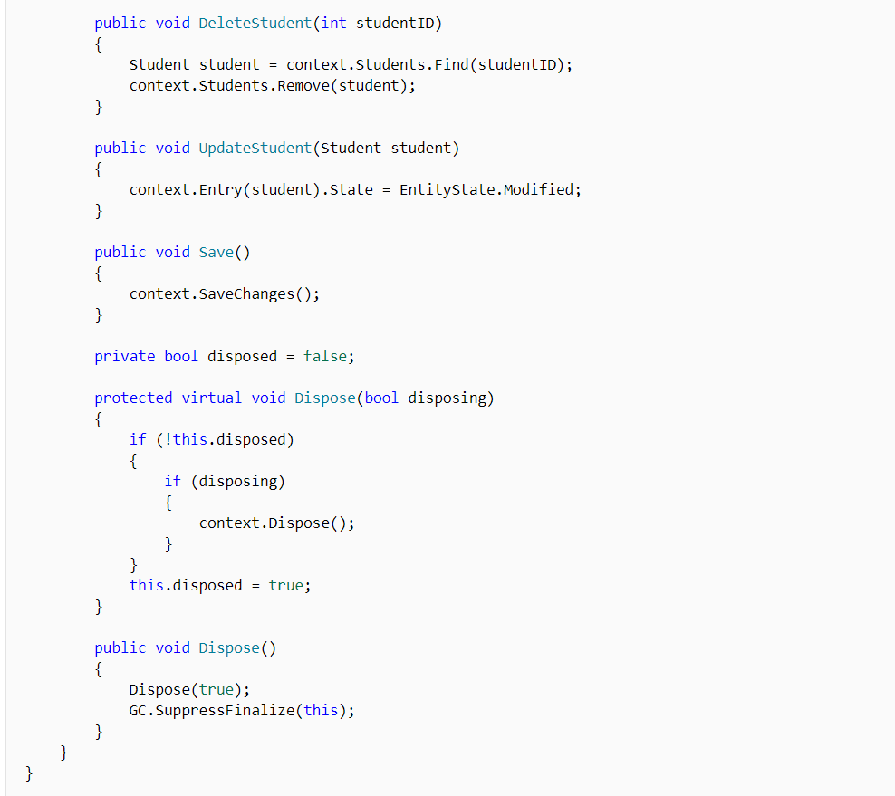

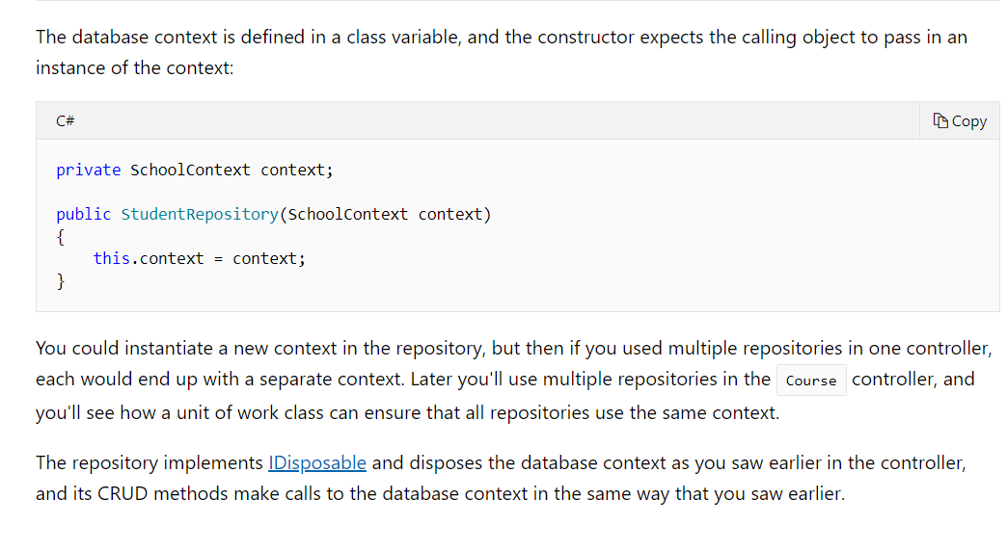

# References

### Repository Tutorial Ref

https://docs.microsoft.com/en-us/aspnet/mvc/overview/older-versions/getting-started-with-ef-5-using-mvc-4/implementing-the-repository-and-unit-of-work-patterns-in-an-asp-net-mvc-application